“I’m happy, I really am.
I’m just tired of doing this life alone.”

On Monday, February 8, 2016, let’s start manifesting your soul mate! We’re going to stop saying statements like the one above and begin Calling In The One.

Join me as I lead you and others through the book:
Calling in the One: 7 Weeks to Attract the Love of your Life.
By Katherine Woodward-Thomas.

- 7 Mondays from 6-8pm
- $100 plus the cost of the book that you will order before the first group
- To sign up call Jenn Fieldman, LPC directly 773-297-9090
- Group location: 138 E Chestnut Street, Asheville, NC

“Sixty six years old, both divorced and widowed, I was feeling like it would be too much to ask for another love at this age. Despite my resistance, fortuitously, Calling In The One and the eight-week support group came into my life at just the right time. I have renewed confidence in myself and more than that a fresh start towards finding the love I deserve and that it’s never too late I would recommend Jenn to anyone for this book group or for personal counseling.”- Nan

This weekly group is designed to be supportive as we figure out how we are getting in our own way when it comes to what we want. The goal is to not only try something new in the way of finding love, but also to connect with others who are also on this path. While it is not guaranteed that you will meet your soul mate by the end of the 7 weeks it is absolutely guaranteed that you will become more mindful about the unconscious patterns that no longer work for you in this love-finding process.

What have you got to lose? Give this a-go!

Jenn Fieldman, Licensed Professional Counselor. 773-297-9090
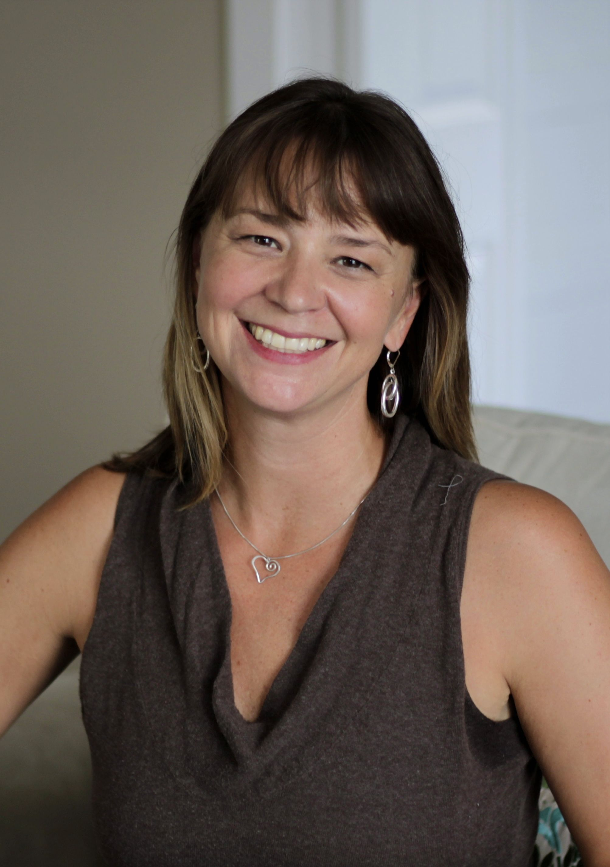
www.jennfieldman.com

